|  |  |
| --- | --- |
|  | **Journal of Rock Mechanics and Tunnelling Technology (JRMTT)**  xx (x) 2024 pp xx-xx  **Available online at www.isrmtt.com** |
| *Manuscript Title in Times New Roman, 16 pt., italic*  *First author1*  *Second author2*  *Authors’ affiliations & address*  *\*E-mail of the corresponding author* | |
| **ABSTRACT**  This document shows the required format and appearance of a manuscript prepared for JRMTT. The abstract consisting of a single paragraph with no more than 250 words is required for Research Articles. The abstract is not necessary for Technical Notes. Reference should not be cited in the abstract. Abstracts need not be in a structured format. However, it should present objectives in brief, the methodology used, key findings and major conclusions drawn from the work. Use of abbreviations in the abstract should be avoided however if essential should be expanded at its first appearance.  ***Keywords:*** Keywords may be given as per requirement and should not exceed six (6 nos.). Characterizing the scope of the paper, Keywords should be written in title case and separated by a semicolon (;). Avoid general and plural terms and multiple concepts (for example, 'and', 'of'). | |

1. **HEADINGS**

Headings should be in UPPER case, bold in 12 pt Times New Roman, meaning all words except for prepositions, articles, and conjunctions should be capitalized.

The manuscript should be written on A-4 size sheet, with right, left, bottom and top margins of 2cm. The manuscript should be written in single space with a letter size of 12 pt in Times New Roman. Page numbers should begin with the title page in Arabic numerals, and all pages should be numbered subsequently.

**1.1 Sub-Heading**

Sub-headings should be in Lower case, bold in 12 pt Times New Roman. Use the decimal system of headings with no more than three levels.

1. **INTRODUCTION**

State the background and mention clearly the objective of the present work.

1. **MATERIALS AND METHODS**

All methods used should be mentioned. This will allow other researchers to reproduce your work. Wherever required, give the correct formula used for calculation and results.

1. **RESULTS**

Results obtained in the study should be subjected to appropriate statistical methods and presented clearly. The findings should never be discussed in this section.

1. **DISCUSSION**

It should have a rationale and be of relevance to the present study along with the existing literature. Discuss the research gap in the area and to how much extent the present study has answered the research question and provide directions for further research. Please avoid repeating the Results of your studies under this section.

**Tables:** Tables should be numbered with Arabic numerals, have a brief caption, and be referred in the text. Column headings and descriptive matter in tables should be brief. Vertical lines should not be used. Numerous small tables should be avoided, and the number of tables should be kept to a minimum.

**Equations and Formulae:** Equations and formulae must be set up clearly and should be typed using Cambria Math in 12 pt. Numbers identifying equations should be in brackets and placed flush with the left margin of the text.

*Example: $E_{d}=\frac{P_{m}(1-ϑ^{2}) }{δ\sqrt{A}}$ (1)*

**Photographs, Figures and Line Diagrams:** All illustrations, whether diagrams or photographs should be of high quality (TIFF, JPEG) and provided within the text, referred to as ‘Figures’ with their captions and numbered in Arabic numerals consecutively as they appear in the text.

Map, line figures or sketches should be provided within the text. Each diagram, map or sketch should carry a suitable title. Letters and numerals in the map, line diagram or sketches should be typed neatly and shall be legible. An example is given in Fig. 1 below.

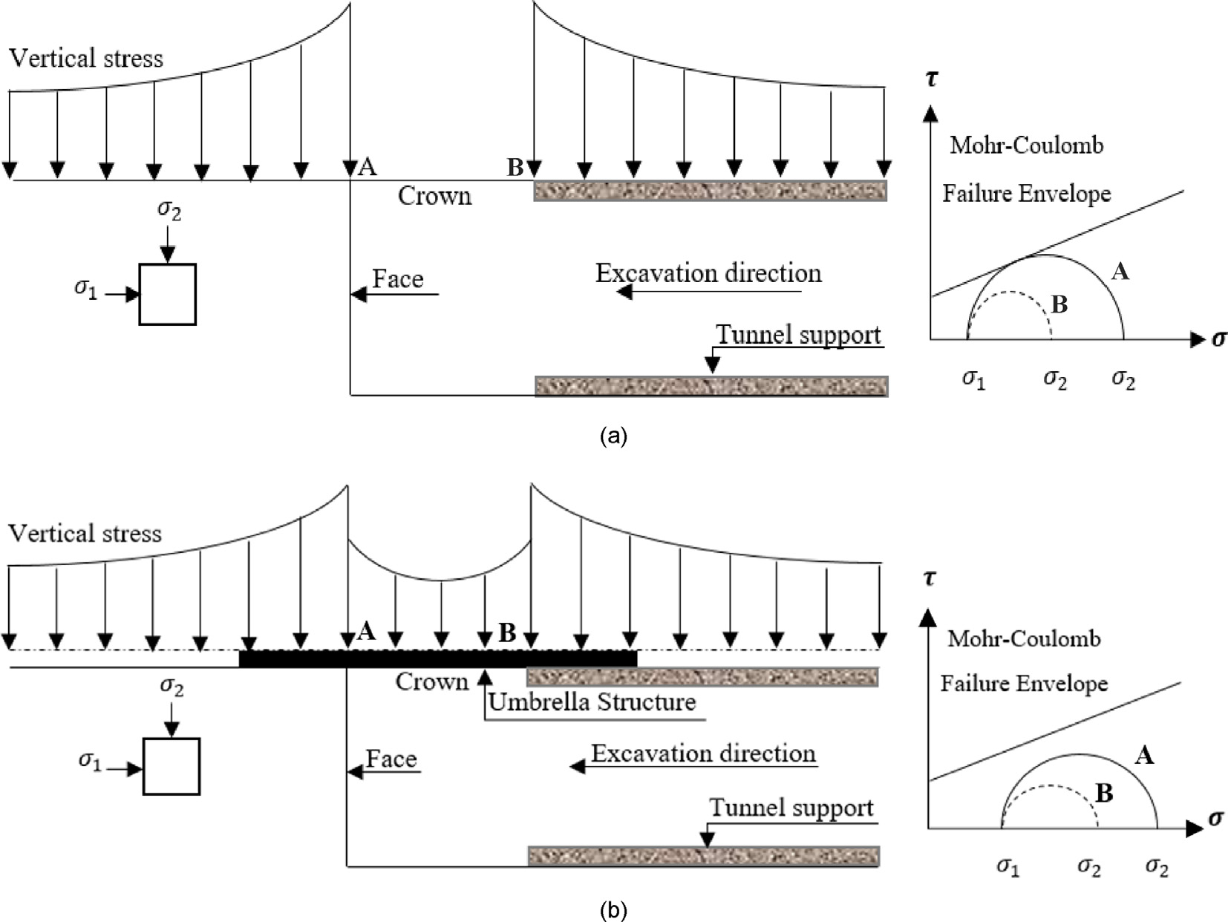

Figure 1 – Figure captions (with proper citation if required)

1. **CONCLUSIONS**

Give the major conclusions from the present study. This section may stand alone or be clubbed together with discussion.

**APPENDIX**

JRMTT does not accept supplementary materials. However, it is permissible to include an Appendix when needed for supplementary material, such as derivations of equations, proofs of theorems, or detailed descriptions of algorithms. Equations and figures within the Appendices should be numbered consecutively, continuing from the numbering used earlier in the paper.

**DISCLOSURES**

Conflicts of interest should be disclosed under a separate header, positioned above the Acknowledgments section. If the authors have no conflicts of interest to declare, a statement confirming this should be included.

**ACKNOWLEDGEMENTS**

Acknowledge those persons who helped you in the present study by providing facilities, personal assistance and funding if any.

***References***

Mitra S and Singh Bhawani (1997). Influence of geological features on long term behaviour of underground powerhouse cavities in lower Himalayan region: a case study. Journal of Rock Mechanics and Tunnelling Technology, 3(1):23-76.

Goel RK, Singh Bhawani, and Zhao Jian (2012). Underground Infrastructures: Planning, Design and Construction, Elsevier Inc., USA, p.334.

Harrison JP, Hudson JA, and Popescu ME (2002). Engineering rock mechanics: Part 2. Illustrative worked examples, p. B30-B31.

Hoek E, Carter TG, Diederichs MS (2013). Quantification of the geological strength index chart. In ARMA US Rock Mechanics/Geomechanics Symposium 2013, pp. ARMA-2013.

Bhasin Rajinder and Thomas P (2013). Dynamic analysis of rock support in tunnels with a case study of a large underground cavern in the Himalayas: Keynote Lecture, Proc. 4th Indian Rock Conference Indorock’2013, May, Solan, India, pp.77-89.

Mitra S (1991). Study on Long-term Behaviour of Underground Powerhouse Cavities in Soft Rocks. Ph.D. Thesis, Department of Civil Engineering, University of Roorkee (now IIT Roorkee), India, p. 193.

Lanzano G, Bilotta E and Russo G (2008). Tunnels under seismic loading: a review of damage case histories and protection method (www.reluis.it/doc/pdf/Pubblicazioni/Lanzano-Bilotta-Russo.pdf), Downloaded in April 2013.

CSMRS (2016). Report on deformability characteristics of rock mass by uniaxial jacking tests in right bank drift D-2 at dam site of Pancheshwar Multipurpose Project, India / Nepal, CSMRS, New Delhi, p. 27.